**2019 Annual Report**

***“To believe in rehabilitation is to believe in humanity”- Dr. Howard Rusk, Founder of WRF***

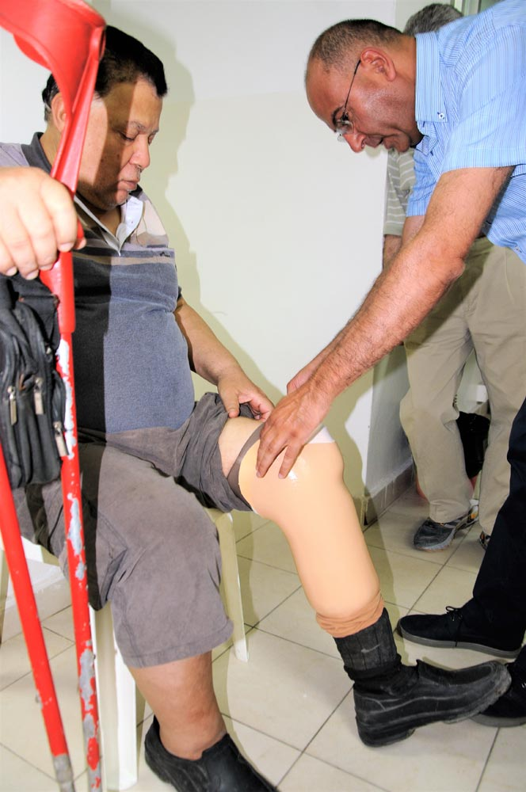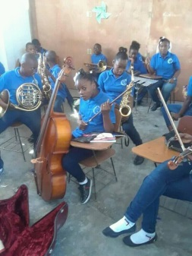

The World Rehabilitation Fund (WRF) continues the legacy of Dr. Howard Rusk to ensure that all people, regardless of disability, have the right to participate fully in their communities, to attain education and viable employment, and have a higher quality of life.

**Our sincerest appreciation goes to the individual donors, private foundations, the U.S. Department of State Bureau of Population, Refugees and Migration (BPRM),) for supporting our work, allowing us to serve people with disabilities in this difficult global climate.**

It is our deepest hope that together we can continue and expand these life-changing, innovative, and transformative programs that continue to benefit people with disabilities around the world.

This report summarizes WRF’s work and impact of programs in

**Lebanon, Haiti, and Guyana.**

during the fiscal year of **July 1, 2019 to June 30, 2020.**

***Serving Syrian Refugees & Lebanese Persons with Disabilities in Lebanon***

The World Rehabilitation Fund was able to continue the effective and efficient implementation of its Project titled **“Filling Assistance Gaps in Basic Rehabilitation Services for Refugees from Syria With Disabilities and Their Peers in Host Communities in Lebanon”** implemented within the context of a Cooperative Agreement awarded by the United States Department of State's Bureau of Population, Refugees and Migration (BPRM) as a Gift of the United States Government.

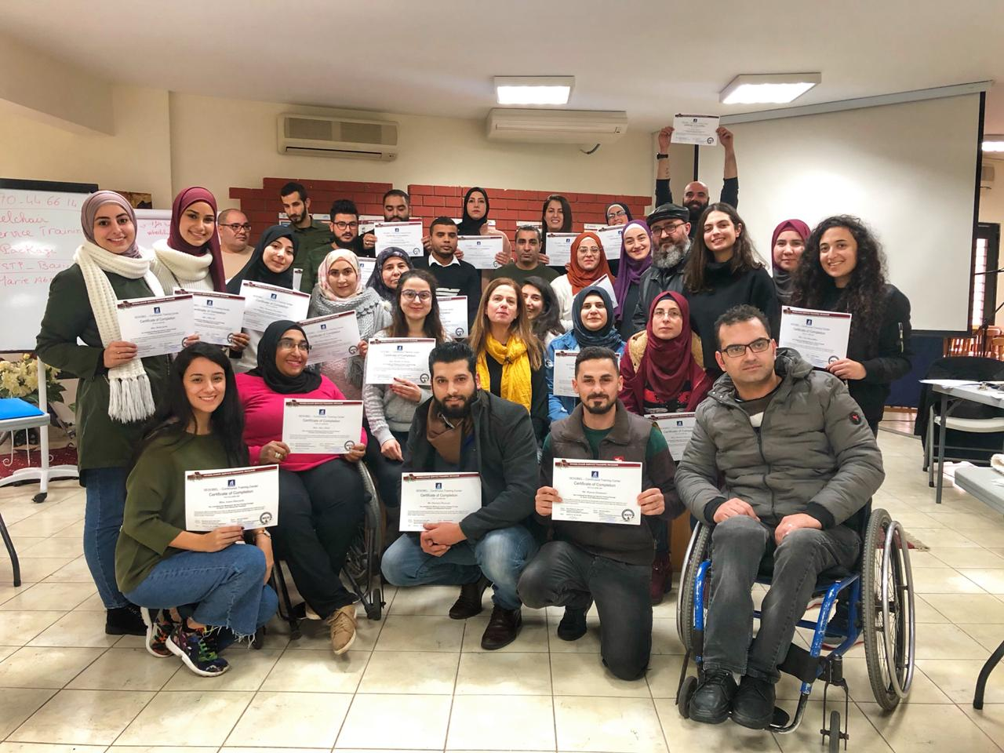 *Participants with their certificates of completion*

In January 2020, the World Rehabilitation Fund (WRF) designed and implemented a capacity building training program titled “Wheelchair Service Training Package (WSTP), in collaboration with SESOBEL. 25 staff members and volunteers from partner Civil Society Organizations (CSOs), participated in the training. Six WRF staff members also attended the three-day training which was conducted within the WRF project titled “*Filling Assistance Gaps in Basic Rehabilitation Services for Refugees from Syria with Disabilities and their Peers in Host Communities in Lebanon.”* Maya Harb, a partner CSO staff member with spina bifida, an active participant in the training and a wheelchair user herself, told her story, “I have been using the wheelchair for at least 13 years and yet I learnt nearly everything I know about wheelchairs during this training. I had no idea what an appropriate wheelchair was.” Maya added, “We live in a world where disability is widely spread. We have, to understand it, assume it and make it our job to try and improve People with Disabilities’ wellbeing.

This despite the challenges associated with:

Deteriorating social, economic, and political conditions in Lebanon that resulted in serious and escalating financial and banking crises. And The COVID-19 pandemic and its resulting consequences. WRF was able to provide person-specific and tailored direct assistance to 3,383 persons with disabilities (PWDs) in need all over Lebanon.

**IMPACT:**

**This year the program has served 3,124 people with disabilities**

* 1,695 were refugees from Syria, 1,331 were Lebanese from host communities, and 98 were other nationalities.
* 1,751 were below 18 years of age.
* 1,661 had vision impairments, 1,051 had physical impairments or disabilities, 400 had hearing impairments, 11 had multiple disabilities and 1 Autism.
* 1,670 of the vision impaired persons were in need of correction aids, mainly eyeglasses. 401 were in need of hearing aids and another 415 needed rehabilitation aids and self/home-care supplies. 292 were in need of orthotic devices, 236 in need of physical therapy, and 146 were in need of prosthetic devices. Some people with disabilities needed more than one type of services.
* Since the inception of the project (September 1st, 2017-June 30, 2020) WRF-Lebanon have serves 7,486 persons with disabilities.

**COVID-19 Challenges & Impact**

Due to the COVID-19 global pandemic and its resulting consequences. The project operations created challenge, and intermittently interrupted, from the middle of March till early June 2020. WRF mobilized to strengthen the resilience of the project team and overall project strength by adapting some of the project approaches and processes to mitigate the impact of the COVID-19 pandemic and national crises. There was a swift transition to use virtual communication as appropriate to enhance coordination, collaboration, wellbeing, and solidarity among all concerned.

Despite these struggles, WRF was able to maintain its proactive role in advocacy, awareness, and resource mobilization in order to expanding assistance to persons with disabilities. Although project implementation continued on track, actual provision of assistance services, and completion of service provision processes were faced with some delays due to the noted crises. Yet, the Project team was able to deal effectively with these delays during June in view of the gradual easing of national lockdown measures.

*Bassan is a 35-year-old Lebanese man who suffered an accident that left him paralyzed from the waist down. To get to work, Bassam used to sit on a wooden board and carefully slide down the stairs from his house on the first floor so he could go to work. In August 2020, WRF installed a customized elevator for Bassam, to help him mobilize around his home with no hassle.*

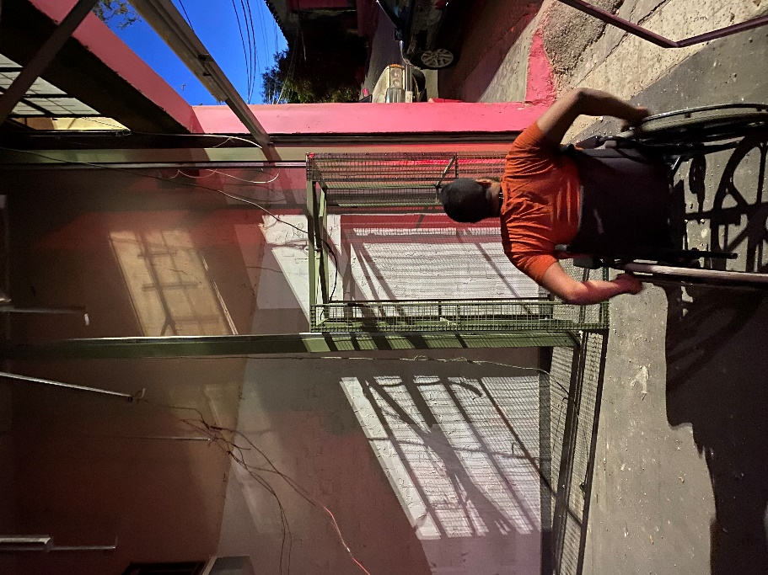 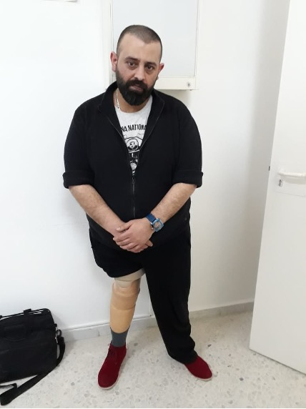

*In March 2020, 39-year-old Youssef received a prosthetic leg from WRF. The prosthetic leg will assist him in obtaining a job so he does not have to rely on others in his daily life.*

***Music for Haiti***

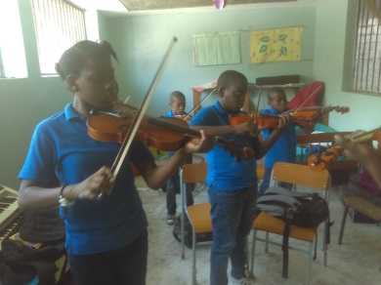*A violin class in action*

What has been achieved at St. Vincent’s since Music for Haiti started eight years ago has been remarkable, especially in light of highly challenging circumstances in Haiti. The school is for children with physical disabilities in Port-Au Prince, Haiti, and is the only school in Haiti offering education and healthcare to children with all varieties of physical disabilities. They serve over 200 children who are deaf, blind, or have other physical disabilities.

For most of 2019, Haiti was in political unrest and things got so bad in autumn that schools (including St. Vincent’s Music School), hospitals, businesses, and churches had no choice but to close until further notice. But once they were able to reopen, they had 44 students enroll, and 32 of them are currently active. Amazingly enough, in Carrefour, SVMS provided instruments for a second campus, away from the center of political violence, and 87 music students enrolled. It was immediately financially self-sufficient.

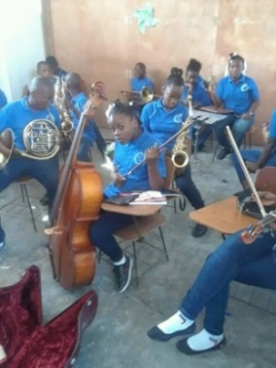

*The Carrefour “proto-orchestra”*

***Targeted Assistance to a Rehabilitation Center in Guyana***



In May 2019, WRF utilized the funds received from an Anonymous foundation for an extremely effective short-term training program in Guyana, to assist the only rehabilitation center with orthotics and braces for people with neurological disorders like cerebral palsy and with severe scoliosis. A team of rehabilitation professionals in Prosthetics, Orthotics, and Physiotherapy addressed the identified problems through hands-on training and fitting of the devices and worked to help improve general management of the facility. The intervention result in a major transformation for the facility in Guyana as the only facility serving people with these types of disabilities.

WRF long standing partner ProsthetiKa, which led the

implementation of the project with funding from various sources.

Completed a 2-week capacity-building project in orthotics and

physiotherapy for neurologic deficits, including orthotic evaluation,

design, fabrication, as well as patient management splinting, scoliosis

management, and therapy training. This training project represented the second in a series of training projects aimed at improving the scope and quality of orthotic, prosthetic, and rehabilitation services in Guyana. The first project conducted in 2018 was in lower extremity prosthetics with adults and children. The second project involved working strictly with children with scoliosis and spinal deformities. In both cases, our team was multidisciplinary consisting of two prosthetist/orthotists and one physiotherapist.

***Unfortunately, due to the COVID-19 global pandemic, this project is currently on hold. The project will resume as soon as it is deemed safe and appropriate by government agencies in Guyana.***

Once again, we wish to thank our incredible donors for believing in the mission of the World Rehabilitation Fund and for supporting the programs of the organization.

Your generosity has allowed us to continue to help persons with disabilities to attain self-sufficiency and for victims of war and disaster to have productive and meaningful roles within their families, communities and nations. It would not be possible without your donations and support.

Respectfully,

WRF staff and Board of Directors